**Assignment 4**

**1 Calculate Total Sales for Each Order.**

db.orders.aggregate([{$unwind: "$products"},{$group: {_id: "$_id",customer_name: { $first: "$customer_name" },total_sales: { $sum: { $multiply: ["$products.price", "$products.quantity"] } }}}])

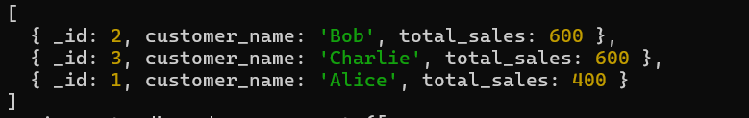

**2 Calculate Average Order Value for Completed Orders**.

db.orders.aggregate([{$match: { status: "Completed" }},{$unwind: "$products"}, {$group: {_id: "$_id", total_order_value: { $sum: { $multiply: ["$products.price", "$products.quantity"] } }}},{$group: {_id: null, average_order_value: { $avg: "$total_order_value" }}}])



**3 Find the Maximum Quantity Sold per Product.**

db.orders.aggregate([{ $unwind: "$products" },{$group: {_id: "$products.product_id", max_quantity: { $max: "$products.quantity" }}}])

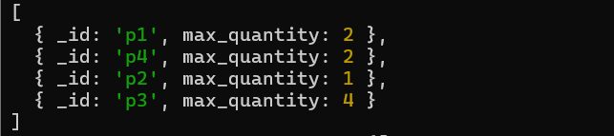

**4 Find Total Number of Orders for Each Status.**

db.orders.aggregate([{$group: {_id: "$status",total_orders: { $sum: 1 }}}])



**5 Calculate Total Quantity of Products Sold Across All Orders.**

db.orders.aggregate([ { $unwind: "$products" }, {$group: {_id: null, total_quantity: { $sum:"$products.quantity" }}}])



**6 Get Minimum and Maximum Order Dates.**

db.orders.aggregate([{$group: {_id: null,min_date: { $min: "$order_date" },max_date: { $max: "$order_date" }}}])



**7 Find Total Sales for Each Customer.**

db.orders.aggregate([{$unwind: "$products"},{ $group: {_id: "$customer_name",total_sales: { $sum: { $multiply: ["$products.price", "$products.quantity"] } } }}])

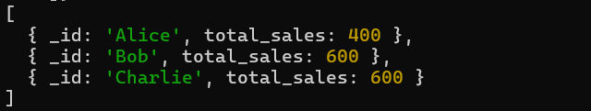

**8 Calculate the Total Number of Distinct Products Sold.**

db.orders.aggregate([{ $unwind: "$products" },{$group: {_id: "$products.product_id"}},{$group: {_id: null,distinct_products: { $sum: 1 }}}])

